Dynamixel Servo Setup Guide

1. Download and Install Dynamixel wizard <https://emanual.robotis.com/docs/en/software/dynamixel/dynamixel_wizard2/>
2. Install OpenCR library on Arduino IDE

Ref: <https://emanual.robotis.com/docs/en/parts/controller/opencr10/#porting-to-arduino-idewindows>

[**Porting to Arduino IDE(Windows)**](https://emanual.robotis.com/docs/en/parts/controller/opencr10/#porting-to-arduino-idewindows)

#### **Preferences**

After Arduino IDE is run, click File → Preferences in the top menu of the IDE. When the Preferences window appears, copy and paste following link to the Additional Boards Manager URLs textbox. (This step may take about 20 min.)

https://raw.githubusercontent.com/ROBOTIS-GIT/OpenCR/master/arduino/opencr_release/package_opencr_index.json

#### **Install the OpenCR package via Boards Manager**

1. Click Tools → Board → Boards Manager.
2. Type OpenCR into the textbox to find the OpenCR by ROBOTIS package. After it finds out, click Install.
3. After the installation, “INSTALLED” will be appeared.
4. See if OpenCR Board is now on the list of Tools → Board. Click this to import the OpenCR Board source.

#### **Port setting**

This step shows the port setting for the program uploads. The OpenCR should be connected to the PC and the OpenCR via the USB ports.

Select Tools → Port → COM1.

**CAUTION** : The value of COM1 may be different depending on the environment connected to the PC.

3. Upload dxl_monitor to OpenCR1.0 Board

* Examples > OpenCR >10.Etc > usb_to_dxl
* Then “Upload”

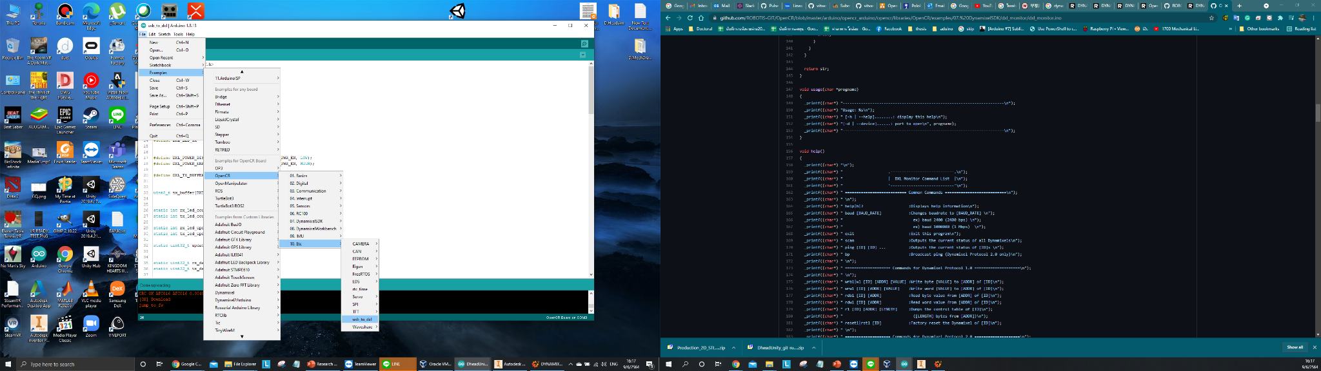

4. Run Dynamixel wizard2.0 >> Scan

** OpenCR must connect to the external power supply when Scan

***First time must set Motor ID one by one because factory default motor have the same ID

* If everything is correct it will show like the below picture (you will see only one motor)

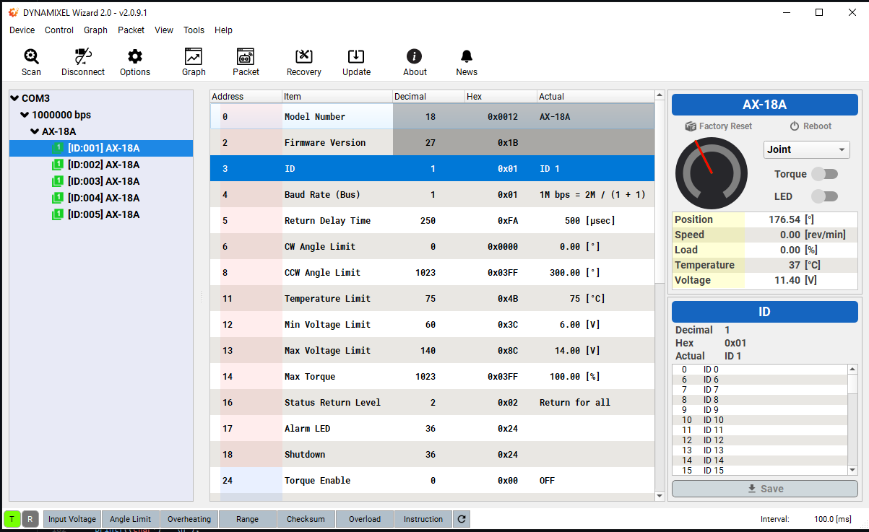

-After that, set ID for each motor (Plug motor in one by one)

-select the motor ID and click “Save”



-The motor ID will run follow number shown in the picture

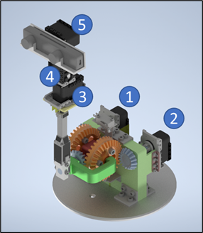

-After finished setup the ID of each motor, The motor ID should show like this when you connected all motor simultaneously

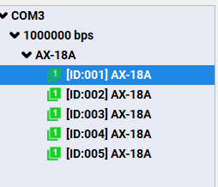

Pinout

